Healthcare in prison

Workbook 3
Getting healthcare



English to help you get access to healthcare in prison.

Contents

Workbook learning goals | Page 3
Workbook 3 – Getting healthcare in prison: Task 1 | Page 3
Workbook 3 – Getting healthcare in prison: Task 2 | Page 6
Workbook 3 – Getting healthcare in prison: Task 3 | Page 10
Workbook 3 – Getting healthcare in prison: Task 4 | Page 14
Workbook 3 – Getting healthcare in prison: Task 5 | Page 17
End of workbook check | Page 19
Workbook 2 Answer key | Page 22

Learning goals

By the end of this unit you will be able to:

- read and understand a notice from healthcare
- understand what the different healthcare services are
- read and understand a healthcare application (app)
- complete a healthcare application for yourself
- understand general health questions.

Task 1 - Reading healthcare information
- What health services do you know? Tick the ones you already know.

- doctor
- dentist
- optician
- chiropodist
- Sexual Health Clinic
- Smoking Cessation
- Mental Health Services
- Well Man Clinic

- Read the leaflet ‘Health Care Information' on page 4 and answer the questions below.
- Who do you talk to first, if you want to get healthcare services in prison? The nurse

- Where are the treatment rooms?_________________

Health Care Information

There is a treatment room on the 1’s landing on each wing.
This is where your get your medication. We also do health screening, including gym fitness checks and hepatitis B vaccinations here.

Talk to the Nurse if you would like to see the
- doctor
- dentist
- optician
- chiropodist
- sexual health clinic
- smoking cessation
- mental health services
- well man clinic

Please come to the treatment room if
- you are unwell
- low in mood
- need medical attention urgently
- have an injury, like a cut or a broken arm
Tell your landing officer if
- you can't walk to the treatment room
- you are feeling low and would like to talk to a Listener or the Samaritans' phone.

- Read leaflet again and tick the best answer in the questions below.

- What can you get in the treatment room?
- Medication
- Smoking clinic
- X-rays

- Why should you come to the treatment room?
- If you are unwell
- If you can't walk
- If you need clean clothes

- When should you talk to your landing officer?
- If you want a hepatitis B vaccination
- If you want to talk to a listener or a Samaritan
- If you want to go to the well man clinic

- Read the sentences about the leaflet. Are they true or false? Write T for true and F for false.
- There is a room on every wing, where you can ask about healthcare. T
- There is a stop smoking clinic on every wing.
- You can get your medicine in the treatment room.
- You can find out about mental health services on the wing.
- You need to speak to an officer before you can go to the treatment room.
- You need to go to the treatment room to ask for a Listener.
- You should go to the treatment room if you are feeling sad.

- Vocabulary
Read the underlined words. Match them with the explanations from the dictionary.
- You are unwell d
- You are in a low mood
- You need medical attention urgently
- You have an injury

Dictionary explanations
- This means you feel sad, but you don't always know exactly why.
- This means the problem must be fixed now, as soon as possible.
- This means something that happens after an accident, like a cut or a broken arm.
- This means ill or sick.

Ask someone for a dictionary in your language or borrow one from the library.
Find the words underlined in task 5.
Write what it says in your dictionary?

unwell _________________________________________
low mood______________________________________
urgently _______________________________________
injury__________________________________________

Task 2 – Speaking about health
- Complete the conversations with words from Task 1.5.

Do you want to speak to a Listener?
I'm in a 1._______ mood
1.

Hello Mr Neale. What's the problem?
Yes. You look very 3.___________ .
Your face is very green!

2.
I feel terrible. I was sick all night and all day yesterday. I need to see the doctor 2._______________.

Yes. Let me see. What happened?
Nurse, my hand hurts! I can't move my fingers.
I hurt it in football.
I think it's quite a bad 4._____________. You need to have an x-ray.
3.

- Asking for services
Mr Baha is talking to the nurse. Read the conversation and answer the questions.
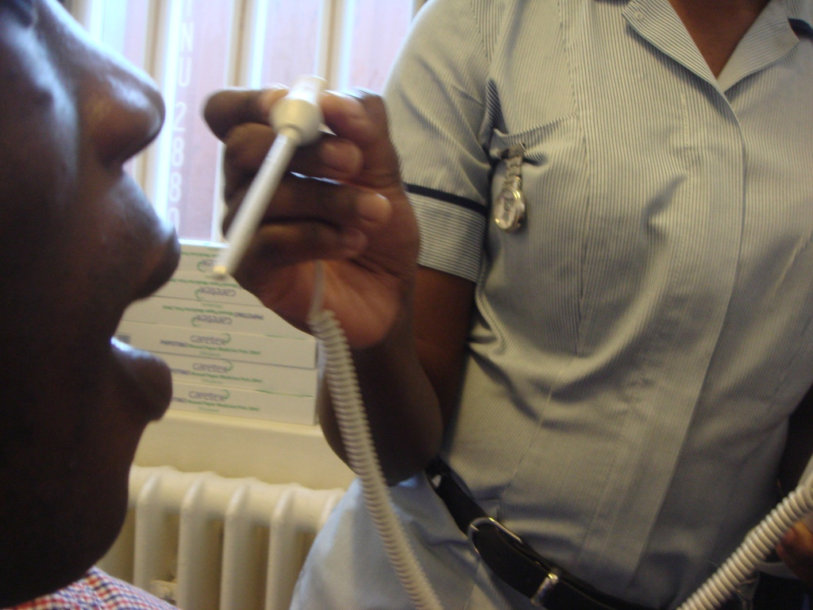

Nurse: Hello Mr Baha, what's the matter?
Mr Baha: Hello nurse. I feel ok, but …. I just want to know for sure if I'm ok…a check over or something like that.
Nurse: You mean a check up – to see if you are fit and well?
Mr Baha: Yes, that's right. A check- up.
Nurse: OK. You need to come to the Well Man Clinic. That's where we do all the health check-ups when you first come here. After that, you come back once a year, if you're still here.
Mr Baha: Right, ok. The Well Man Clinic.
Nurse: Yes. But you need to fill in an app – an application form - first. Here you are.
Mr Baha: Thanks
- Is Mr Baha unwell? no
- What does Mr Baha want?_________________________
- Where does he need to go? ________________________
- What does he need to do first?______________________
- How often does he need to go to the Well Man Clinic? ____________

- Now write the correct words for the different services next to the pictures.
optician mental health dentist smoking cessation chiropodist
well man clinic sexual health clinic nurse
 | 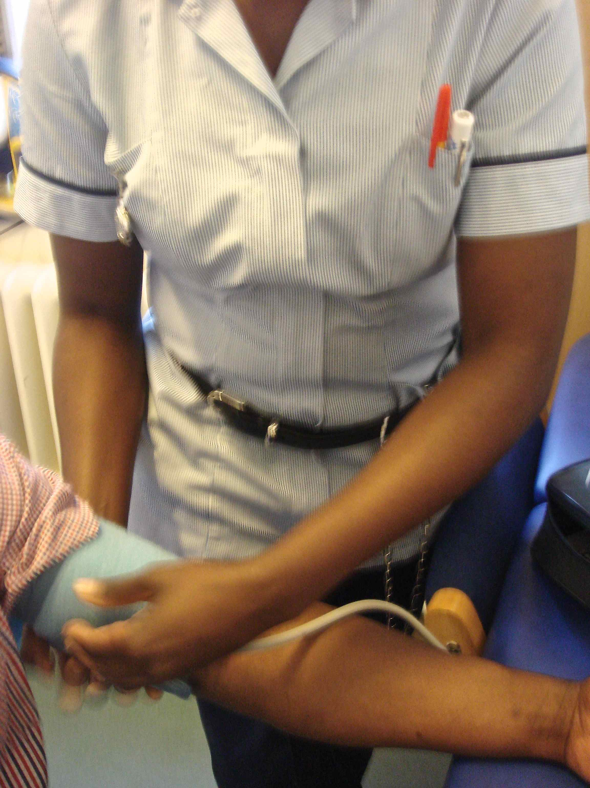
 | 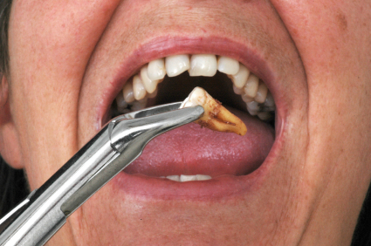
Sexual health clinic
 | 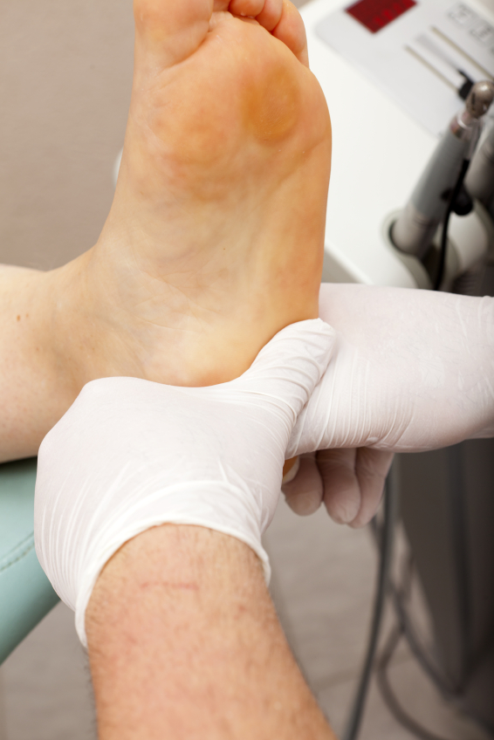
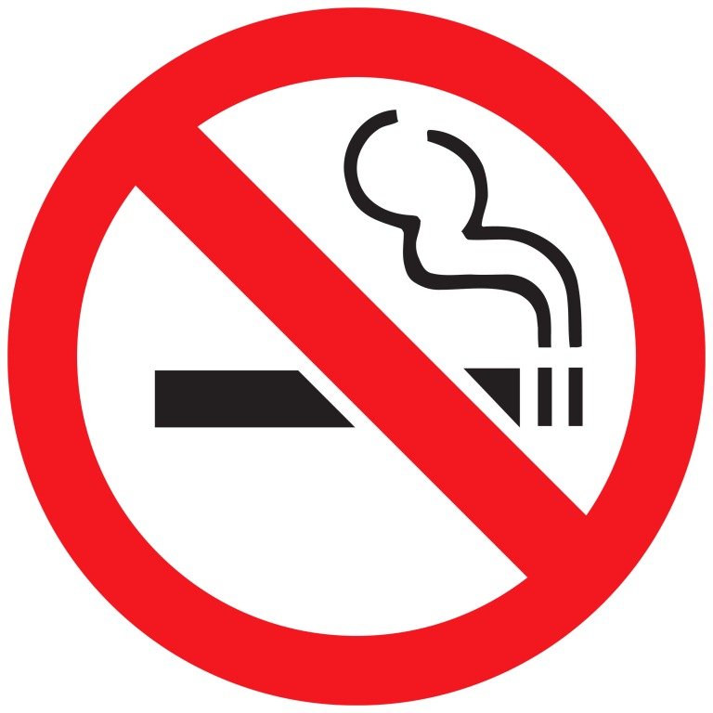 | 

Now check your answers.

Task 3 – Filling in an app
- Healthcare application: Mr Baha fills in his application, but there are three mistakes on his form. Can you find them? Circle his mistakes.

Healthcare application
FULL NAME Lenny ______ NUMBER A047291
CELL J21 DATE _____________
PLEASE TICK THE PERSON YOU WISH TO SEE |  | DOCTOR
OPTICIAN |  | NURSE
SEXUAL HEALTH CLINIC |  | DENTIST
MENTAL HEALTH |  | CHIROPODIST
SMOKING CESSATION |  | WELL MAN CLINIC

- Asking and answering questions at the clinic

Mr Perez is at the Well Man Clinic. The nurse asks him some questions.


Write the words in the right order, to make the questions.
- are old How you? How old are you?
- do much you How weigh? _____ ______ _____ _____ _______?
- tall How you are? ______ _______ ______ _________?
- Do smoke you? ____ _____ _________?
- any Do exercise you do? _____ _____ _____ _____ ___________?
- you Do problems any heart in your family have? ____ _____ _____ ____ _______ __________ ____ _____ _________?
- Are taking medication you any? _____ _____ ______ _____ ________?
- health Do have any you worries? ____ _____ _____ ____ _____ _______

Check your answers on the next page.

- Match the questions to Mr Perez's answers.

  Nurse's questions |   Mr Perez's answers
- How old are you? f) | - I go to the gym once a week.
- How much do you weigh? | - Yes, just tablets for my diabetes.
- How tall are you? | - No…I stopped last month.
- Do you smoke? | - My father had a bad heart.
- Do you do any exercise? | - 75kg
- Do you have any heart problems in your family? | - 54
- Are you taking any medication? | - No. I feel fine, but I just want to be sure.
- Do you have any health worries? | - 1.8 metres

Now check your answers.

- What about you? Can you answer these questions about yourself? Use Mr Perez's answers to help you.
- How old are you?
- How much do you weigh?
- How tall are you?
- Do you smoke?
- Do you do any exercise?
- Do you have any heart problems in your family?
- Are you taking any medication?
- Do you have any health worries?

Ask someone in healthcare for some information. Do they have a Well Man clinic? What other clinics do they have to help you? Write them in this list.

Healthcare services in my prison:
1.
2.
3.
4.
5.

- Fill in the healthcare application for yourself.

Healthcare application
FULL NAME _________________________ NUMBER _____________
CELL ______________ DATE _____________
PLEASE TICK THE PERSON YOU WISH TO SEE |  | DOCTOR
OPTICIAN |  | NURSE
SEXUAL HEALTH CLINIC |  | DENTIST
MENTAL HEALTH |  | CHIROPODIST
SMOKING CESSATION |  | WELL MAN CLINIC

Task 4: Understanding a gym fitness check

Ask someone in healthcare for some information. What day can you go to the gym?
How often can you go?
1.
2.

- Before you can use the gym, you have to answer questions for a gym fitness check. Match the questions to the pictures.

-  | - 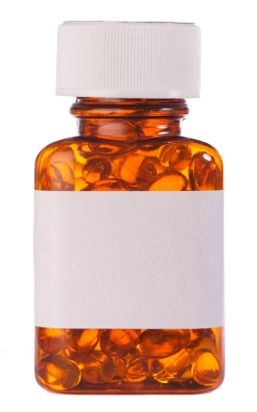 |  | - 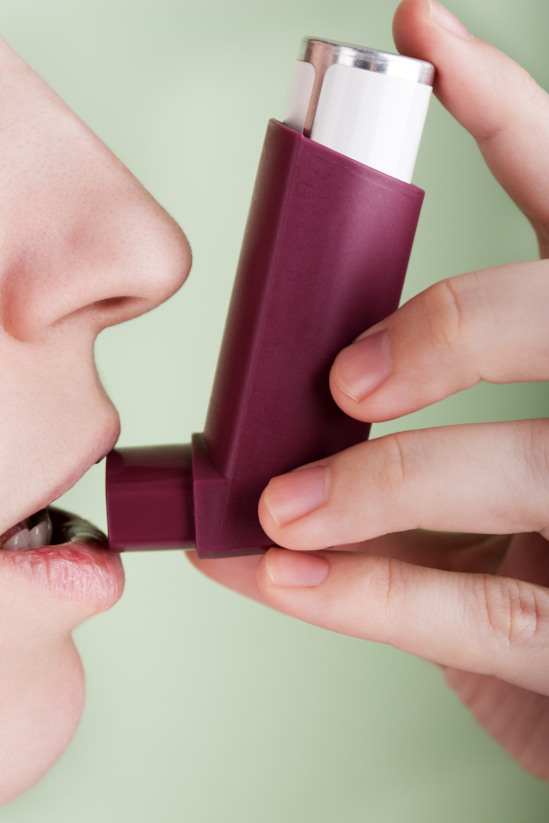
- 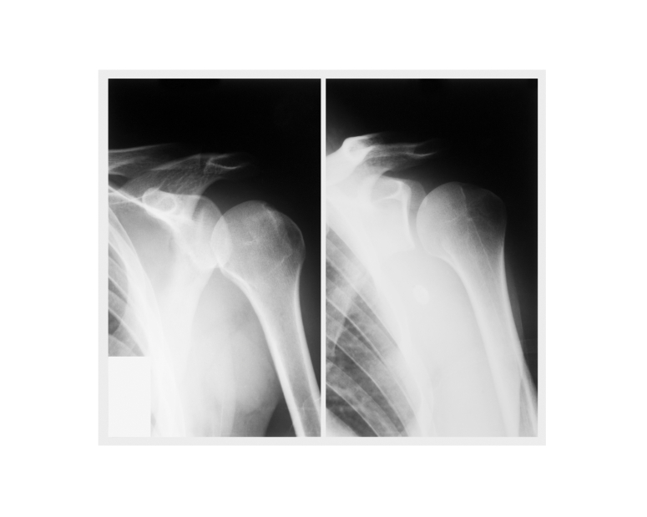 | - 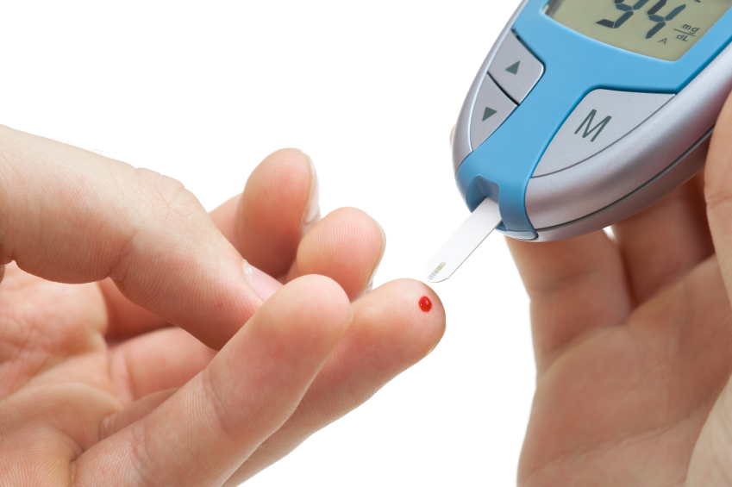 |  | - 
-  | -  |  | - 
- Have you ever drunk alcohol? |  | - Do you suffer stress in your daily life?
- Do you smoke? |  | - Do you have back, joint or muscle problems?
- Do you have any allergies like hayfever? |  | - Are you diabetic?
- Are you on any medication?? |  | - Do you have asthma or breathing problems?
- Are you on a detox?

Look back at your word lists from Healthcare Workbooks 1 and 2 to help you.

- Understanding the gym fitness check. Match the questions with the answers
- Have you ever drunk alcohol? | - No, I've never had anything serious like that.
- Do you smoke? | - I hurt my knee playing football but I think it's ok now.
- Do you have any allergies? | - I sometimes get asthma if I have a bad cold.
- Are you on any medication? | - No. I've never used drugs.
- Do you suffer stress in your daily life? | - I'm stressed in here, but it's OK.
- Do you have back, joint or muscle problems? | - No. I stopped smoking last year.
- Are you diabetic? | - Yes, I’ve got hayfever.
- Do you have asthma or breathing problems? | - Yes, I drink about two or three beers a week, on the out.
- Are you on a detox? | - Just paracetamol sometimes.

Ask someone in healthcare for some information. What extra gym sessions are there? Who can go?
1.
2.
3.

- What about you? Can you answer these gym fitness questions about yourself? Use the phrases in the speech bubbles
I used to drink……..cans/ bottles/ pints a day / a week
I smoke about …….. a day
- Have you ever drunk alcohol? How much did you drink?
- Do you smoke? How many cigarettes do you smoke a day?
Yes. I'm allergic to………………….

- Do you have any allergies?
Yes. I 'm on….. for…….
- Are you on any medication?
Yes. I find it hard to ………………….. I feel …………… about …………….

- Do you suffer stress in your daily life?
- Do you have back, joint or muscle problems? Where does it hurt?
It's my…………..
It happens when I ……………
- Are you on a detox? When did you start?
It was…….. days/ weeks ago.

Task 5 – Word games
All the words are in Workbook 3. Use your wordlist to help you. You can also check your answers at the back of the book
Crossword
 |  |  | - s |  |  | 2. |  | 2.
 |  |  | m
4. |  |  | o
 |  |  | k
 |  |  | i
 | 5. |  | n |  |  |  |  |  |  |  | 6.
 |  |  | g |  |  |  | 7.
 |  |  |  |  |  | 8.
 | 9.
 |  |  |  | 10.
 | 11.
12.

Across
1. S________ health clinic, for illnesses of your penis or testicles.
4. The nurse will check your b_______ pressure at the well man clinic.
5. If you feel stressed and need help, talk to the m_____ health team.
7. This is when you stop using drugs or alcohol
9. You see this person when you are very ill. He can find the right medicine for you.
10. When you go to the well man clinic, you can have a c ______ up.
11. there is a smoking c______ clinic to help you stop smoking.
12. If you have a serious injury, you sometimes go to hospital for s_______ .

Down
1. You do this if you use cigarettes
2. This means ill or sick.
3. Ask to speak to a l_________ if you feel low or sad.
5. Sometimes, you are in a low _______ and feel very sad.
6. You go to the gym or play sport to get this.
8. If you need a doctor ______, then you can't wait.

Word list – new words about accessing healthcare
Write the word in your language.

Healthcare services | translation | Medical words | translation
Sexual health clinic |  | Injury
Smoking cessation |  | Detox
Samaritans |  | Unwell
Listener |  | Low mood
Well man clinic |  | Supplement
Vaccinations |  | Dizziness
Gym fitness check |  | Asthma
Check up |  | hepatitis

End of Healthcare Workbook 3: progress check

1. What can you remember?
- Where can you get healthcare information on the wing?
The t_______________ r_________.

- Who can you speak to if you feel in a low mood?
A L____________.

- What can you find out about, when you speak to the nurse?
- The s______ health clinic
- The W____ M____ clinic
- The s________ Cessation clinic
- V___________
- A G______ F________ C________

2. Read the sentences and reorder them into a conversation between a nurse and a patient.
Nurse: | Let's start with questions about your lifestyle. Do you smoke?
Patient: | Yes.
Nurse:
Patient:
Nurse:
Patient:
Nurse:
Patient:
Nurse:

- About 15, sometimes 10.
- Do you take any tablets?
- Only at the weekend. Just a few pints or a few cans. I don't drink a lot.
- Are you on any medication?
- OK. What about alcohol. Did you drink on the outside?
- Just multivitamins, sometimes.
- OK. That's fine. No more questions for now.
- No.
- How many do you smoke a day?

End of unit check

Now you have finished this unit, how do you feel? Tick () the box that is true for you.

 | Yes | A little | No
I can read and understand information about how to get healthcare
I understand what the different healthcare services are
I can read and understand a healthcare application (app)
I can complete a healthcare application
I can understand and answer general health questions

Workbook 3 Answer s
Task 1- Reading healthcare information
1.2
a the nurse
b on the 1's landing on each wing

1.3
1a
2a
3b

1.4
- T
- F
- F
- T
- F
- F
- T

1.5
1d
2a
3b
4c

Task 2 – speaking about health
1.1
1 low
2 urgently
3 unwell
4 injury

1.2
1. no
2. a check-up
3. the well man clinic
4. fill in an application (app)
5. once a year/every year

Task 3 – filling in apps
1.1
- Full name: he forgot his surname
- He forgot to write the date
- He underlined nurse. He should tick √ Well Man clinic
1.2
- How much do you weigh?
- How tall are you?
- Do you smoke?
- Do you do any exercise?
- Do you have any heart problems in your family?
- Are you taking any medication?
- Do you have health any worries?

1.3
1a
2e
3l
4i
5g
6k
7b
8c
9h
10 j
11 d
12 f

Task 4.1
-  | -  | - 
Have you ever drunk alcohol? | Are you on any medication? | Do you have asthma or breathing problems?
-  | -  | - 
Do you have back, joint or muscle problems? | Are you diabetic? | Are you on a detox?
-  | -  | - 
Do you suffer stress in your daily life? | Do you smoke? | Do you have any allergies like hayfever?

2
- Have you ever drunk alcohol? | Yes, about two or three beers a week, on the out.
- Do you smoke? | No. I stopped last year.
- Do you have any allergies? | Yes I’ve got hayfever.
- Are you on any medication? | Just paracetamol sometimes.
- Do you suffer stress in your daily life? | I'm stressed in here, but it's OK.
- Do you have back, joint or muscle problems? | I hurt my knee playing football but I think it's ok now.
- Are you diabetic? | No, I've never had anything serious like that.
- Do you have asthma or breathing problems? | I sometimes get asthma if I have a bad cold.
- Are you on a detox? | No. I've never used drugs.

Task 5 Crossword
 |  |  | 1.s | e | x | 2. u | a | 3.l
 |  |  | m |  |  | n |  | i
- b | l | o | o | d |  | w |  | s
 |  |  | k |  |  | e |  | t
 |  |  | i |  |  | l |  | e
 | 5. m | e | n | t | a | l |  | n |  |  | 6. e
 | o |  | g |  |  |  | 7. d | e | t | o | x
 | o |  |  |  |  | 8. u |  | r |  |  | e
 | 9. d | o | c | t | o | r |  |  |  |  | r
 |  |  |  |  |  | g |  |  |  |  | c
 |  |  |  | 10. c | h | e | c | k |  |  | i
 |  |  |  |  |  | n |  |  |  |  | s
 | 11. c | e | s | s | a | t | i | o | n |  | e
 |  |  |  |  |  | l
12. s | u | r | g | e | r | y

End of unit 3 progress check.
1. What can you remember?
1. The treatment room.
2. A Listener.
3.
- The sexual health clinic
- The Well Man clinic
- The smoking cessation clinic
- Vaccinations
- A Gym Fitness Check

2.
Nurse: | Let's start with questions about your lifestyle. Do you smoke?
Patient: | Yes.
Nurse: | How many do you smoke a day?
Patient: | About 15, sometimes 10.
Nurse: | OK. What about alcohol? Did you drink on the outside?
Patient: | Only at the weekend. Just a few pints or a few cans. I don't drink a lot.
Nurse: | Are you on any medication?
Patient: | No.
Nurse: | Do you take any tablets?
Patient: | Just multivitamins, sometimes.
Nurse: | OK. That's fine. No more questions for now.

